Optical Fiber Cleaver Instruction Manual
- Technical Specifications:
Applicable range | Single Core silex-fiber | Cleaving Angle | ≤0.5°
Coating Diameter | φ0.25＆φ0.9 | Weight | 355g
Fiber Diameter | 125μm | Blade Life | 48000 times
Cleave Length | 5-20mm | Dimension | 60mm(W)×58mm(D) ×52mm(H)
- Operation procedure:
- Facing the blade shelf and open the big pressboard and small pressboard.(See figure 1)
- Use the stripper to strip the coating of fiber, reserve 30-40mm bare fiber, use pledget which is dipped by absolute alcohol to cover and clean the fiber, avoid using the same pledget twice.
- Align the stripped fiber with calibration and put it into V-groove and make sure that the bare fiber is sticking out of the rubber pad exactly in a straight line.
- Close the pressboard and push the blade shelf to another side to cut the fiber.
- Hold the cleaver with left hand, open the big pressboard with right hand and clean the fiber chip.
- Use left hand to hold the fiber and open the small pressboard with right hand, remove the cleaved fiber carefully without touching the end face.
- Maintenance:
- Blade height adjustment: please operating as following step when does not work sell:
- Push the blade shelf to another side to make the screw II align the aperture on the bottom of cleaver, then release screw II with wrench.
- Revolve the adjust axle in the middle of blade shelf slightly (See figure 2).
- Lock screw II and I tightly. (Screw II fix adjust axle and screw I fix blade).
- Repeat above steps till blade is in proper position.
- Blade position adjustment:
- Release screw I on the blade shelf.(See figure 2)
- Cleaver revolves 45 degree, insert sharp thing into operation aperture and revolve the blade to make blade on the point of 1-12 or 1-16.
- Press the blade with finger and lock screw I tightly.
- Blade replacement:
- Release screw II and I, pull out the adjust axle (See figure 2).
- Release the screw of blade shelf, lean down the cleaver 45 degree and put the new blade into blade shelf.
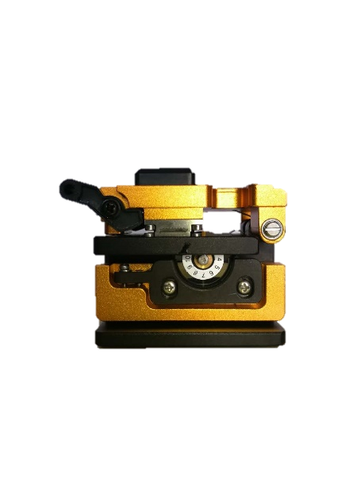
- Push the adjust axle into the central aperture or revolve adjust axle with screwdriver and the align position I up to lock the screw.
High lock screw 2
Height adjusting screw 3
Screw 1
- Put the coating fiber in the φ0.9 groove to adjust blade height, revolve adjust axle to make blade touch the fiber, then adjust half calibration to proper position and lock screw I and II tightly.
Screw 1
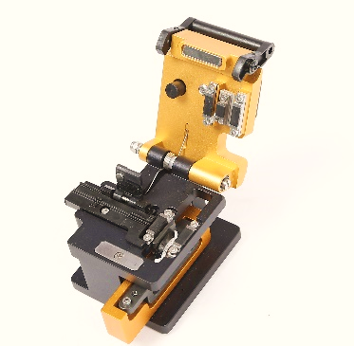
big pressboard
small pressboard.
blade shelf
blade

