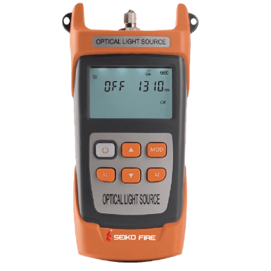
Light Source S100
Features
Support cw and a variety of modulation light output
Output optical power adjustable, Adjustment range 6dB, step 1dB (optional).
Support automatic shutdown
Backlight intelligent control
Supports single wavelength, combined wavelength customization (1490nm, 1625nm)
Specifications
Center wavelength | 850/1300(MM) | 1310/1550(SM)
Optical Connector | FC/SC/ST
Wavelength | 850/1300/1310/1490/1550/1625/1650nm
Power stability (dB) | 0.02
Laser type | FP-LD
Output power | ≥-5dBm
Short-term stability | ±0.05dB/15min
Long-term stability | ±0.15dB/8h
Way of working | CW, 270Hz/1kHz/2kHz
Operating temperature | -10~+60℃
Storage temperature | -30~+70℃
Working humidity | 5%~95%RH
Continuous working time | ≥80h
Structure size | 100mm×50mm×186mm
Power | Three section 5 batteries/Lithium battery (optional)
Instrument net weight | 240g

