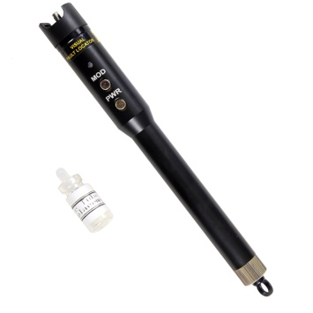
Visual Fault Locator S207
This is specially designed for field personnel who need an efficient and economical tool for fiber tracing, fiber routing and continuity checking in optical network.
Features
Metal case, Rugged and durable
Low battery indication, to avoid leakage and wrong judgment
ESD protection design, Protect the LD effectively
Integrated case, to avoid the case intermediate broken
Re-changeable ceramic tube, to avoid returning to manufacturer for this small fault
Long battery life, up to 60 hours＠1mW
Specifications
Central Wavelength | 650nm±10nm (635nm can be required on request)
Emitter Type | FP-LD
Output Power (mw) | 1, 10, 20, 30, 50
Optical Connector | 2.5mm universal connector  For 1.25mm connectors, FC (Male)-LC (Female) convertor  can be optional on customer’s requests
Operating Model | Both CW and Pulse available
Pulse Frequency | 2~3Hz
Power Supply | 2 AA alkaline batteries
Battery Operating Time | 650nm@1mw ≥65hours  650nm@10mw≥15hours  Test with Panasonic LR6 AA ALKALINE battery
Operating Temperature (℃) | -10~+45
Storage Temperature (℃) | -40~+70
Dimension (mm) | ￠15X210
Weight(g) | 120(Without battery)

