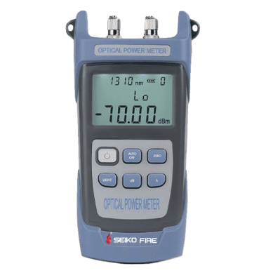
Power Meter S300
Features
Support linear mw and nonlinear index dBm simultaneous display
Support automatic shutdown
Support backlight selection
Support user self-calibration
Support restore factory settings
Supports FC, SC, and ST interfaces
Working time is longer than 120 hours
Specifications
Wavelength range | 800nm~1700nm | 800nm~1700nm
Optical Connector | FC/SC/ST | FC/SC/ST
Detector type | InGaAs | InGaAs
Measurement range | -70dBm~+10dBm | -50dBm~+26dBm
Accuracy | ±5%
Standard wavelength | 850/980/1300/1310/1490/1550/1625/1650nm
Display resolution | mw: 0.1%, dBm: 0.01
650nm VFL (optional) | 2mw/5mw/10mw/20mw/30mw/50mw
Laser source (optional) | 850/1300/1310/1490/1550/1625/1650nm
Laser source stability | 0.02dB
Working temperature | -10~+60℃
Storage temperature | -30~+70℃
Auto off time | 10 min
Battery continuous operating time | ≥120 h
Structure size | 186mm*100mm*50mm
Power | Three section 5 batteries/Lithium battery (optional)
Instrument net weight | 240g

