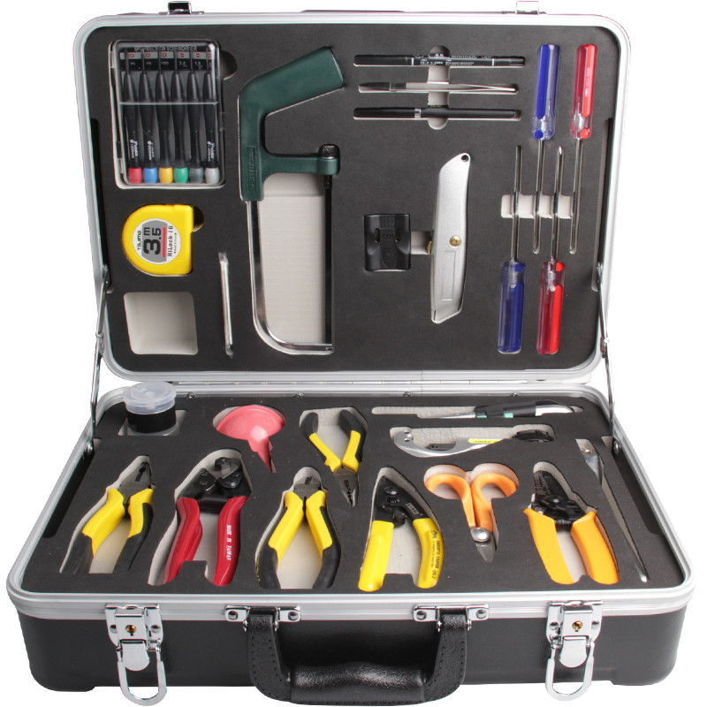
Fusion Splicing Tool Kit S63
QUICK OVERVIEW
The S63 tool kit is ideal for optical fiber fusion splicing. It includes all the most frequently need tools and supplies required for cable sheath removal and fusion splicing.
Fiber Fusion Splicing Tool Kit S63 is manufactured by SeikoFire, it's ideal for fiber optic fusion splicing.
SeikoFire offers a range of tool kits for cabling instruction, such as the FTTH Quick Termination kits, Fiber Optic Cleaning Kits, Fiber Optic Fusion Splicing tool kits, Fiber Testing Kits with high quality and fast delivery.
SeikoFire can also OEM the Fiber Optic Tool Kits according to customers requirements. Tell us your needs and SeikoFire will be your reliable partner.
Fusion Splicing Tool Kit S63 includes
Fiber optic Kevlar cutter(KS-1) | 9Pcs Folding type hex key set (inch)
Fiber Stripper(CFS-2) | Screwdriver S/D(-)5×100mm
Round Cable Slitter | Screwdriver S/D(+)#1×100mm
Optical Fiber Jacket Stripper | Screwdriver S/D(-)6×100mm
Wire Rope Cutter | Screwdriver S/D(+)#2×100mm
Round Cable Cutter | 4 oz.Bottle of Alcohol
Carbide fiber scribe | Fiber Cleaning Wipes
6Pcs Electronic Screwdriver Set | Blow Brush
7'' Lineman's plier 178mm | Utility knife(TAJIMA)
6'' Needle Node Pliers 135mm | 3.5M Tape Measure(TAJIMA)
6'' Side Cut Pliers 130mm | Precision tweezer
8" Adjustable wrench | Black Marker
Mini-Hacksaw | Carrying Tool Case(430×330×135mm)

