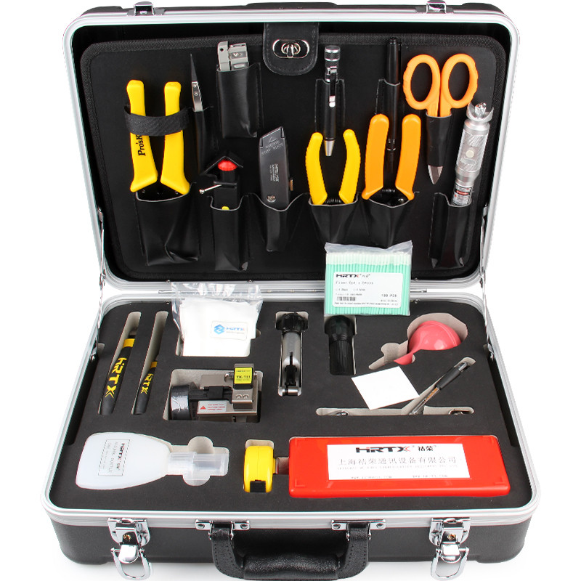
Fiber Optic Fusion Splicing Tool Kit S65

QUICK OVERVIEW
The S65 tool kits is ideal for optical fiber fusion splicing. It includes all the most frequently need tools and supplies required for cable sheath removal and fusion splicing.
Fiber Fusion Splicing Tool Kit S65 is manufactured by SeikoFire, it's ideal for fiber optic fusion splicing.
SeikoFire offers a range of tool kits for cabling instruction, such as the FTTH Quick Termination kits, Fiber Optic Cleaning Kits, Fiber Optic Fusion Splicing tool kits, Fiber Testing Kits with high quality and fast delivery.
SeikoFire can also OEM the Fiber Optic Tool Kits according to customers’ requirements. Tell us your needs and SeikoFire will be your reliable partner.
Fiber Optic Fusion Splicing Tool Kit S65 includes
Fiber Optical Stripper(CFS-2) | Emergency lamp
Optical Fiber Jacket Stripper | 6" Adjustable wrench
Fiber optic Kevlar cutter(KS-1) | Fusion Splice Sleeves 60mm
Pocket Visual Fault Locator (Optional) | Fiber Cleaning Wipes 7.5*7.5mm, 50/pkg
High Precision Fiber Cleaver (Optional) | 250ml Bottle of Alcohol with Lock
Universal fiber Cable Slitter (3.2-35mm) | 2.5mm Foam Tipped Fiber Optic Swab
Longitudinal Cable Sheath Slitter KMS-K | Pre-Moistened Alcohol Wipes
Ideal 45-162 Buffer tube stripper | 3M Electrical Tape
6-IN-1 Mini Pen-style Screwdriver | Blow Brush
6'' Needle Node Pliers 135mm | Utility knife
6'' Side Cut Pliers 130mm | 3.5M Tape Measure
6-IN-1 Magnetic Quick Change Screwdriver | Precision tweezer
Round Cable Cutter | Black Marker
7Pcs Folding type hex key set (inch) | Carrying Tool Case (430×330×135mm)

